Experiment-5

Aim :To Study and Implementation of Rasberry Pi

objective:To study Rasberry Pi

Theory:

What is Rasberry Pi?

Raspberry Pi is the name of a series of single-board computers made by the [Raspberry Pi Foundation](https://www.raspberrypi.org/about/), a UK charity that aims to educate people in computing and create easier access to computing education. The original Pi had a single-core 700MHz CPU and just 256MB RAM, and the latest model has a quad-core CPU clocking in at over 1.5GHz, and 4GB RAM. The price point for Raspberry Pi has always been under $100 (usually around $35 USD), most notably the Pi Zero,

2. Arduino vs Rasberry Pi (min 5 Points)which costs just $5.

| **Raspberry Pi** | **Arduino** |
| --- | --- |
| Raspberry Pi is a Single Board Computer or SBC | Arduino is a Microcontroller based development board |
| It is based on Broadcom SoC, an ARM Cortex A Series Microprocessor | It is based on Atmel Microcontrollers. Arduino UNO uses ATmega328P Microcontroller |
| A Debian based Linux Distribution called Raspberry Pi OS is needed to boot the Raspberry Pi | As it is a Microcontroller, there is no need for an operating system |
| Raspberry Pi SBC can preform multiple tasks simultaneously due to its powerful processor and Linux based OS | Arduino is usually used for running a single task (or a very small no. of simple tasks) repeatedly, over and over again |
| All the necessary components like Processor, RAM, Storage, Connectors, GPIO Pins, etc. are situated on the Raspberry Pi Board itself | The Microcontroller on the Arduino Board (like ATmega328P) contains the Processor, RAM, ROM. The board contains supporting hardware (for power and data) and GPIO Pins |

Pin Diagram of Rasberry Pi: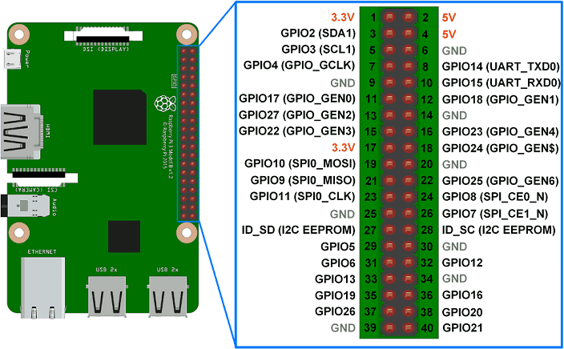

Architecture:

The ARMv8-A architecture, which encompasses the 64-bit AArch64 architecture and associated A64 instruction set, was first introduced into the Raspberry Pi line with Raspberry Pi 3 in 2016.

* ARM11J6JZF-S (ARM11 Family)
* ARMv6 Architecture
* Single Core
* 32-Bit RISC
* 700 MHz Clock Rate
* 8 Pipeline Stages
* Branch Prediction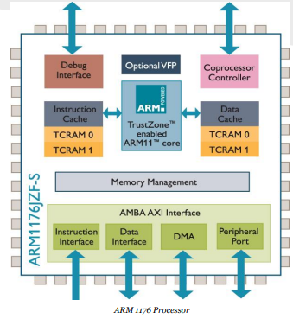

Real time Example:

## [**Motion Capture Security System**](https://www.makeuseof.com/tag/build-a-motion-capture-security-system-using-a-raspberry-pi/) Using Raspberry

Raspberry Pi Camera Module attached, or a generic USB webcam, you can build a motion capture security system.This Raspberry Pi project combines the motion software with uvccapture, a tool for capturing the footage from your webcam. The ffmpeg software is also used to manage the bitrate and time lapse. Once it's all up and running, you can expect the system to start recording whenever motion is detected. Email alerts can also be configured.

Conclusion: Thus, we studied about raspberry pi a [series](https://www.educba.com/what-is-raspberry-pi/) of small, single-board computers developed to teach computer science basics to school students and other people in low-income countries. It became a popular and easy to experiment tool to develop school projects, hardware programming, robotics, basic automated machines, circuits, etc. The Uses of Raspberry Pi is a small, quite affordable, and very much [capable hardware device](https://www.educba.com/types-of-computer-hardware/) called a credit card size computer.